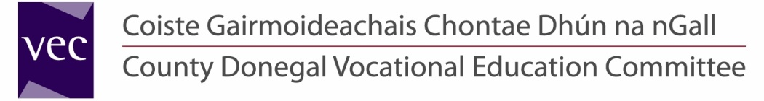

The Donegal Music Education Partnership is currently seeking applications from suitably qualified candidates for a panel of casual, part-time Instrumental/Vocal Tutors for posts which may arise at various locations throughout the county. Tutors delivering the modules/programmes on a part-time basis will be offered fixed term/specified purpose contracts.

Preference will be given to applicants who hold an appropriate third level qualification (BA with Music or B. Mus.) or a relevant equivalent and/or diploma in your chosen instrument/voice. Those with professional experience in performance and/or tutoring of their instrument/voice shall also be considered.

Successful candidates should hold a full and current driving licence and will be subject to Garda Vetting procedures.

**Rate of Pay:** €32.79 per hour, including holiday pay. (New Entrants – €29.51 per hour, including holiday pay)

**The closing date for the return of completed application forms is 12:00 noon on Thursday, 24th January 2013.**

**Please note:**

* Completed application forms will not be accepted via e-mail.
* Shortlisting of applicants may take place.
* Late applications will not be considered.

**Contact Details:**

Linda Harley

Human Resources Division

County Donegal Vocational Education Committee

Administrative Offices, Ard O’Donnell, Letterkenny, Co. Donegal

T: (074) 9161510 F: (074) 9161544 E-mail: [linda@donegalvec.ie](mailto:linda@donegalvec.ie)

**County Donegal Vocational Education Committee is an Equal Opportunities Employer.**

**Cuirfear fáilte roimh chomhfhreagras i nGaeilge.**

|  |
| --- |
| VEC SML Colour.jpgDonegal Music Education Partnership LOVES:livemusic |
| 10198 EU-ERDF English RGBcdb logoCREST DCC |

**Projects Supported by PEACE III Programme**

**managed for the Special EU Programmes Body**

**by Donegal County Council**