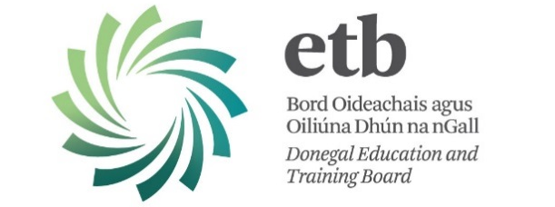

A chara,

Donegal ETB currently make payments to Suppliers, Staff and Members of the Board and Sub-Committees by Electronic Funds Transfer (EFT) only.

Please Note:
A Republic of Ireland Bank Account is required for EFT payment.
Failure to supply the required information below will result in payments being withheld pending receipt of the information requested below.

Therefore, we request that you complete in full and return the ELECTRONIC FUNDS AUTHORISATION below to:

Aidan Mc Closkey,
Local Youth Club Grants Committee
Donegal ETB, Ard O’Donnell, Letterkenny, Co. Donegal

Name of Club/Group
Account Name
Treasurer’s Name |  |  |  |  |  |  |  |  |  |  |  |  | Telephone No.
Address |  |  |  |  |  |  |  |  |  |  |  |  | Email
R.O.I. Bank Name & Address
 | IBAN No
 | BIC / SWIFT No
 | Account No |  |  |  |  |  |  |  |  |  |  |  |  |  |  |  |  |  | Bank Sort Code
 | Tax Ref Number |  |  |  |  |  |  |  |  |  |  | CHY Number

I hereby authorise Donegal ETB to lodge all payments due to this Club/Group, to the account details supplied herewith. I undertake to repay any payment(s) lodged to this Bank Account, to which I am not rightfully entitled. I declare that all information supplied by me in relation to the above is both true and accurate.

Signature: _________________________ Date ________________
Treasurer
Please have you bank affix its official stamp to confirm  the details provided are true and accurate. | [Official Bank Stamp]

