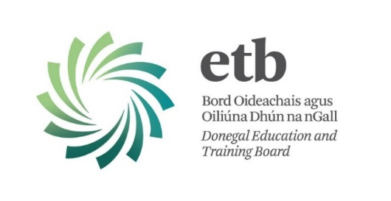

Youthreach is a full-time quality assured education programme which caters for early school leavers (aged 15-20 years) who have limited formal educational qualifications. Youthreach offers FETAC-accredited practical/creative, interpersonal and core education skills programmes in a supportive non-formal environment.

Donegal Education and Training Board (ETB) seeks applications from suitably qualified persons for the following positions which may arise for the 2014/2015 session:

**Ref No.: Post:**

**YR02: Counsellor (Therapeutic) for Youthreach Programme Participants**

**YR03: Supervision of Programme Delivery Staff**

Both positions are located at the Youthreach Programme, Ballyshannon.

**The Applicant:**

Applicants must possess an appropriate third level qualification and be a member of an appropriate professional organisation, e.g. ICP, IACP, IAHIP, PSI.

**Closing date for receipt of completed applications is 12:00 noon on Tuesday, 9th September 2014.**

**Please note:**

* Completed application forms will not be accepted via e-mail.
* Shortlisting of applicants may take place.
* Late applications will not be considered.

**Contact Details:**

Application forms and further information available from:

Aidan Mc Closkey, HR Operations Officer,

Donegal ETB, Administrative Offices, Ard O’Donnell, Letterkenny, Co. Donegal

T: (074) 9161595 F: (074) 9161544 E-mail: [aidan@donegaletb.ie](mailto:aidan@donegaletb.ie)

**Youthreach is co-funded by the Irish Government and EU under the National Development Plan.**

 