**PRESS RELEASE - DMEP CONCERT**

Donegal Music Education Partnership Intergenerational Music Concert

DONEGAL MUSIC EDUCATION PARTNERSHIP PRESENTS: **The Intergenerational Music Concert, featuring the** **Donegal Intergenerational Music Ensemble (DIME) and the Errigal Singers,** at the **Regional Cultural Centre, Letterkenny**, on **Wednesday 7th May** at **7pm**.

This concert will celebrate some of the wonderful work that has been carried out over the past 18 months by our intergenerational instrumental and choral groups, **DIME** and the **Errigal Singers**, and is taking place as part of **The 17th Annual Bealtaine Festival 2014**. **Bealtaine Festival** celebrates creativity in older age through a series of workshops, events and concerts, involving older people as performers, audience members and event organizers.

**This concert will take place at the Regional Cultural Centre, Letterkenny on Wednesday 7th May, 2014 at 7PM**

**This is a free concert and is open to the public.**

**Tickets can be booked at: 074 91 29186**

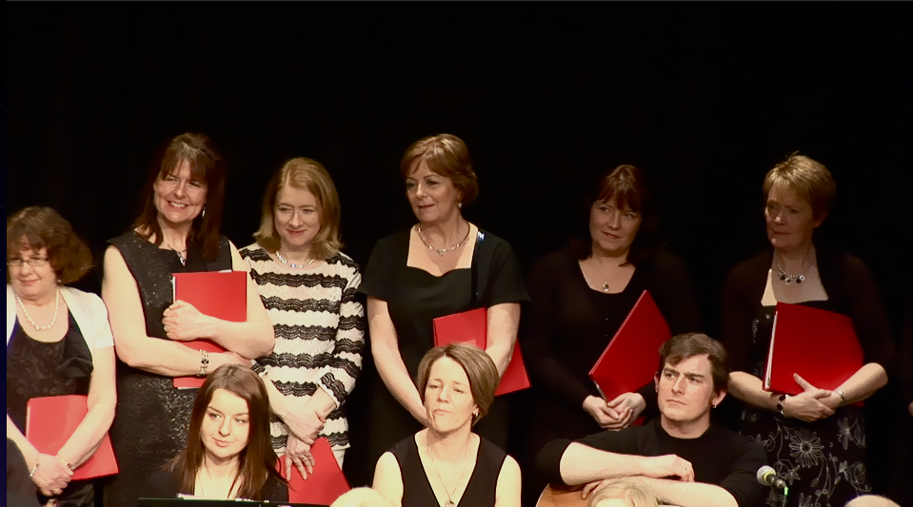 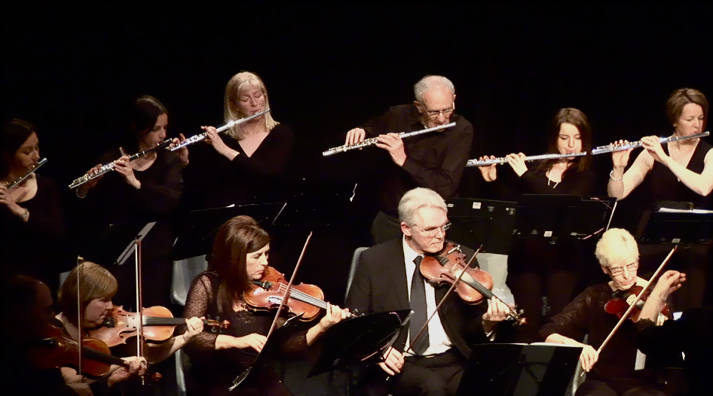

The **Errigal Singers**, our intergenerational choral group, will open the concert, led by their conductor **Lorna McLaughlin**, who will lead them in a varied repertoire of folk, world and classical music. In the second half of the concert, **DIME**, led by conductor and violinist **Irene Donnelly** – who together with fiddle-player **Seamus McGuire** has led the ensemble through the process of learning and listening over the last 18 months – will perform a repertoire of traditional, folk and classical pieces.