DONEGAL ETB
AWARDS 2013/2014
Students/Learners/Staff

“New opportunities for students? A better connection between bright new ideas and what we do in
Donegal ETB ? Preparing our community of learners to find new and marketable solutions to the challenges of tomorrow?”

These are the goals that will underpin the Awards For A More Innovative Community Of Learners in Donegal ETB. A team of judges from the different areas within the organisation will consider the submitted initiatives/projects and announce the winners. Entries can be submitted by those involved in the project or by any member of Donegal ETB staff, student or learner body at any time up to the closing date of the 30th April 2014.

For further information please contact annualawards@donegaletb.ie and/or visit our website at www.donegaletb.ie

Opportunities for winning awards will be in the following areas:-

1. RESEARCH
(This award will be presented for the best piece of research done by a student, a group of students or member(s) of staff in any appropriate area).

2. TECHNOLOGY IN EDUCATION
(This award will be presented for the most effective integration of technology in teaching & learning).

3. INNOVATIVE THINKING
(This award will be presented to a student or teacher (or group of same) who has identified a problem and implemented a solution that had a positive impact).

4. CO-OPERATION WITH LOCAL ORGANISATIONS
(This award will be presented for the most valuable project carried out in collaboration with local organisations).

5. INCLUSIVE PROJECT
(This award will be presented for the best initiative promoting inclusion)

6. GREEN PROJECT (SUSTAINABLE ENERGY)
(This award will be presented for the best project promoting the green environment).

7. GOOD PRACTICE IN HEALTH
(This award will be presented for the best initiative promoting healthy living).

8. STEAM (SCIENCE TECHNOLOGY ENGINEERING ARTS MATHEMATICS)
(This award will be presented for the best initiative in merging the arts and STEM education.)

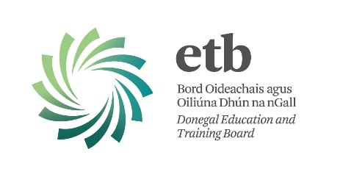
Application Form

DONEGAL ETB AWARDS
Students/Learners/Staff 2013/2014

Name of Applicant(s): ________________________________________________________________________________________________________________________________________________________________________________________________
________________________________________________________________

Contact Details:
Tel: ______________________________________________________
Email: ______________________________________________________

School/ College/Centre/Location:
________________________________________________________________

Award Category (see list):
________________________________________________________________
________________________________________________________________
________________________________________________________________

Details:
Please give a brief description of your proposal, no more than 200 words. ______________________________________________________________________________________________________________________________________________________________________________________________________________________________________________________________________________________________________________________________________________________________________________________________________________________________________________________________________________________________________________________________________________________________________________________________________________________________________________________________________________________________________________________________________________________________________________________________________________________________________________________________________________________________________________________________________________________________________________________________________________________________________________________________________________________________________________________________________________________________________________________________________________________________________________________________________________________________________________________________________________________________________________________________________________________________________________________________________________________________________________________________________________________________________________________________________________________________________________________________________________________________________________________________________________________________________________________________________________________________________________________________________________________________________________________________________________________________________________________________________________________________________________________________________________________________________________________________

I am enclosing attachments: Yes/ No

Please give details of any attachments
________________________________________________________________________________________________________________________________________________________________________________________________
________________________________________________________________________________________________________________________________
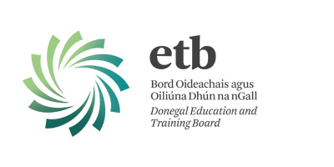Donegal ETB

AWARDS
2013/2014

Date for your Diary:-

Please Submit by Wednesday, 30th April 2014

We are reminding you to submit your application for the Awards.

We would ask you to kindly pay particular attention to the following notes in order to make the processing more efficient:-

Please state clearly the Category of Award for which you are submitting
Submissions are by Official Application Form – from www.donegaletb.ie
Completed Application Forms to be emailed to specified email address: annualawards@donegaletb.ie
Supporting documentation/material to be handed in at Reception.
The Closing Date of 12.00 noon on 30th April 2014 will be strictly adhered to.

Good Luck to you all and we look forward to seeing your entries!

Application Forms and further information available on Website

Entries can be submitted by those involved in the project or by any member of Donegal ETB staff, student or learner body at any time up to the closing date of the 30th April 2014.

Opportunities for winning awards will be in the following areas.

1. RESEARCH
(This award will be presented for the best piece of research done by a student, a group of students or member(s) of staff in any appropriate area).

2. TECHNOLOGY IN EDUCATION
(This award will be presented for the most effective integration of technology in teaching & learning).

3. INNOVATIVE THINKING
(This award will be presented to a student or teacher (or group of same) who has identified a problem and implemented a solution that had a positive impact).

4. CO-OPERATION WITH LOCAL ORGANISATIONS
(This award will be presented for the most valuable project carried out in collaboration with local organisations).

5. INCLUSIVE PROJECT
(This award will be presented for the best initiative promoting inclusion)

6. GREEN PROJECT (SUSTAINABLE ENERGY)
(This award will be presented for the best project promoting the green environment).

7. GOOD PRACTICE IN HEALTH
(This award will be presented for the best initiative promoting healthy living).

8. STEAM (SCIENCE TECHNOLOGY ENGINEERING ARTS MATHEMATICS)
(This award will be presented for the best initiative in merging the arts and STEM education.)

