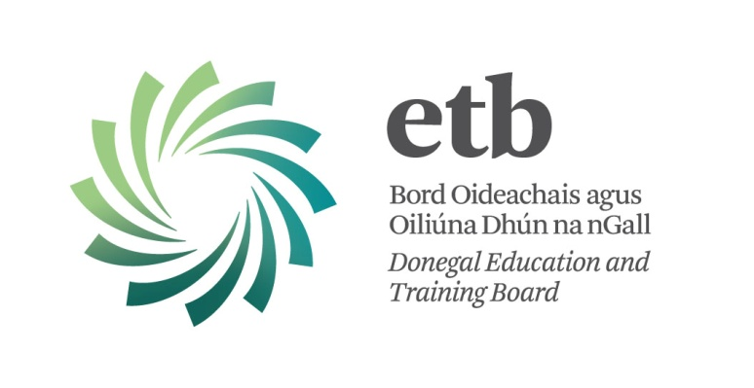

Substitute Teacher Panel 2013/2014

Donegal ETB will be accepting applications for the Substitute Teacher Panel 2013/2014 from Monday, 12th August 2013.

Application forms will be available here on www.donegaletb.ie at that time.

If you submitted an application form for the 2012/2013 panel, and you wish to be included on the 2013/2014 panel, you need not complete another application form, but you must send an email to Aidan Mc Closkey, aidan@donegaletb.ie, providing evidence of your Teaching Council Registration for the 2013/2014 session.

Important Note:
Only application forms from teachers who are registered with the Teaching Council of Ireland for the 2013/2014 session will be accepted. Teachers who are not registered with the Teaching Council are not eligible for the Substitute Teacher Panel.

Please refer to Circular 0025/2013 on the website of the Department of Education and Skills.

Keep up to date with Donegal ETB – Like us on Facebook

