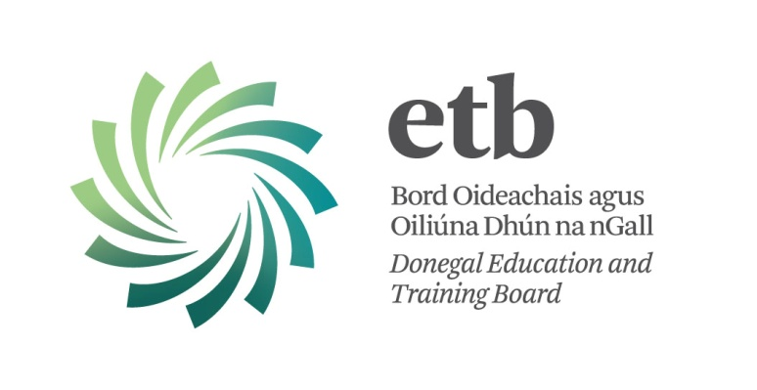

Adult Education Vacancies

Vacancies for the Board’s Adult Education Service are filled from a number of Tutor Panels in different subject areas for the various FETAC Levels to which programmes are delivered.

Admission to these tutor panels is by interview only and, from time to time, Donegal ETB invites suitably qualified persons to submit application forms when such panels are advertised on the Board’s website and/or in the local press.

We are not currently accepting applications for the Adult Education Panels.

Keep up to date with Donegal ETB – Like us on Facebook

