ETB Community Art Exhibitions

A number of art exhibitions will be taking place across the county as part of the celebrations to launch Donegal Education and Training Board, formerly Co. Donegal VEC.

Community Education Facilitator, Méabh Mhic Gairbheith, will open a week-long exhibition to showcase art from classes all around Donegal supported by ETB Community Education. This exhibition will also include some excellent pieces from Youthreach trainees in Letterkenny Centre for Education. The exhibition will take place in Letterkenny Shopping Centre, from Monday 21st to Saturday 26th October, from 12:00noon to 5:00pm daily.

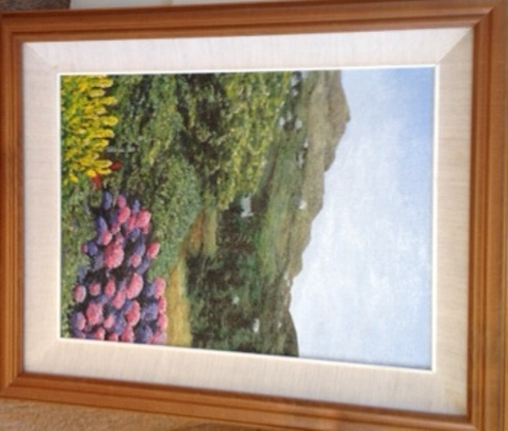

Image 1
Hydrangeas by Colette Mc Devitt, Glencolmcille Art Group

Students form Magh Éne College, Bundoran will be displaying their work and celebrating their creativity in a week-long exhibition at Bundoran Town Library and Post Office through the week of celebrations.

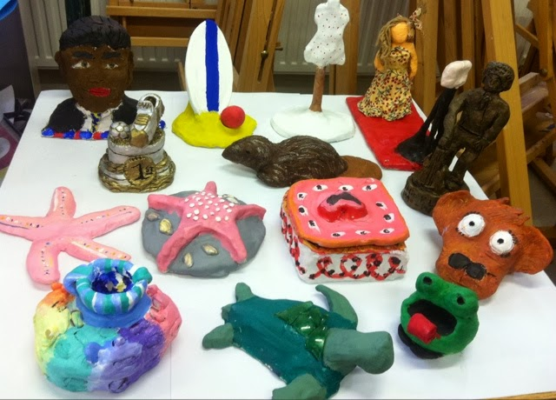
A selection of 3D pieces in Clay form Magh Éne College

Trainees from Youthreach in Gortahork, Lifford and Ballyshannon will exhibit selections of their arts and crafts in their respective Centres and in the local communities that they are part of.

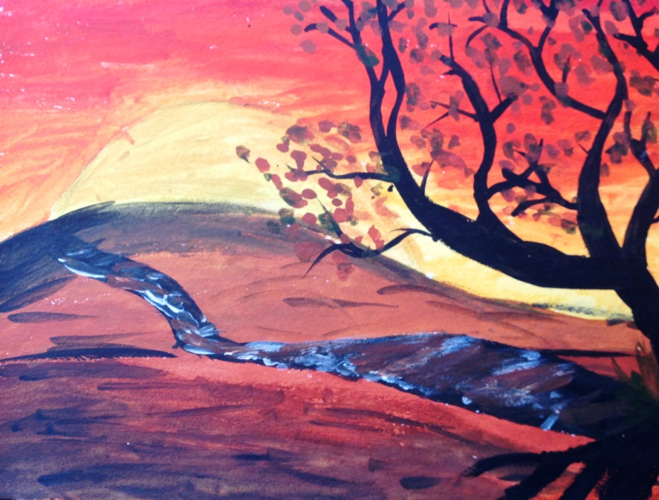

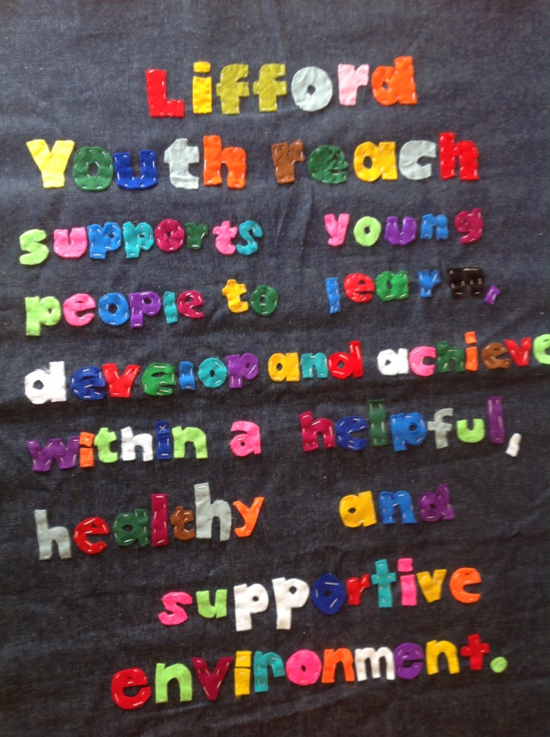

Samples of work from Youthreach trainees in Lifford.

Make sure you get along to enjoy the exhibitions in your area.

