Donegal ETB 5K Fun Walk/Run

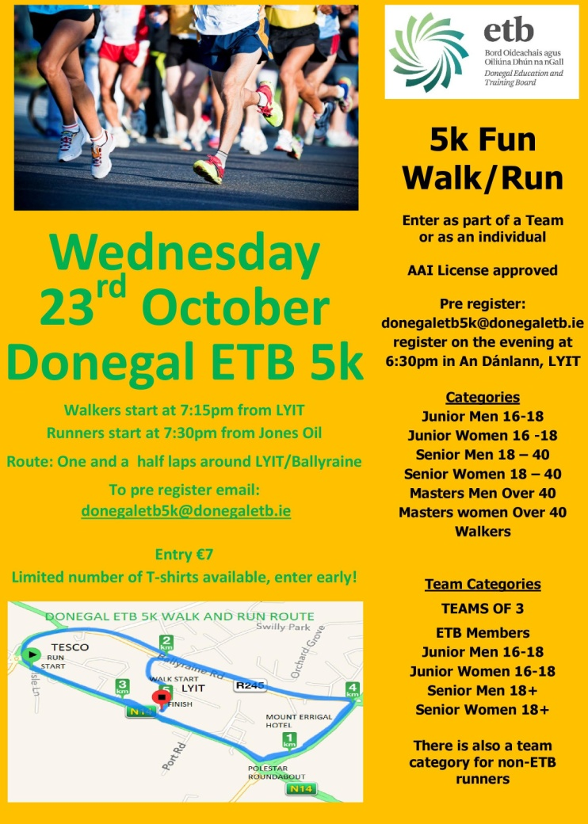
Donegal ETB will hold its first 5K on Wednesday, 23rd October 2013.

On a flat and fast course so there’s plenty of scope for personal bests!

Walkers start at 7:15pm from LYIT
Runners start at 7:30pm from Jones Oil

Pre-register by email to donegaletb5k@donegaletb.ie

Walkers 7:15pm Start
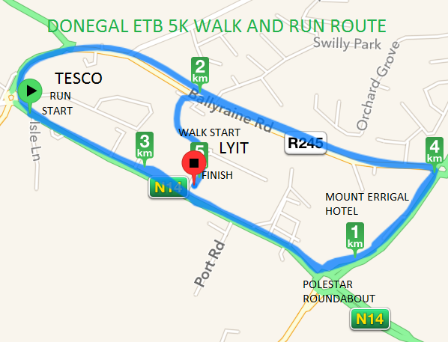
Starting at the roundabout within the LYIT campus , turning left at the IT exit continuing along the Port Road, turning left at the Polestar Roundabout towards the Mount Errigal Hotel, turning left at the 1st roundabout in the direction of Ballyraine N.S. continuing straight on towards the Station Roundabout, taking the second exit back onto the Port Road, continuing on past the front of the IT back onto the route they have already travelled, turning left at the Polestar Roundabout, left at the next roundabout in the direction of Ballyraine N.S, and when they reach the back of the IT they turn left into the college and walk around the right hand side of the College, following the road around until they approach the Campus Roundabout where they started but this time continuing on to the right in the direction of the main front exit. The finish line is located in front of the IT Sports Hall.
Runners 7:30pm Start
Beginning at Jones’ Oil close to the Station Roundabout, continuing along the Port Road past the front of the IT, turning left at the Polestar Roundabout towards the Mount Errigal Hotel, turning left at the 1st roundabout in the direction of Ballyraine N.S. continuing straight on towards the Station Roundabout, taking the second exit back onto the Port Road, continuing on past the front of the IT back onto the route they have already travelled, turning left at the Polestar Roundabout, left at the next roundabout in the direction of Ballyraine N.S., and when they reach the back of the IT they turn left into the college and run around the right hand side of the College, following the road around until they approach the Campus Roundabout where they continuing on to the finish line which is located in front of the IT Sports Hall.
Good Luck Everyone!

