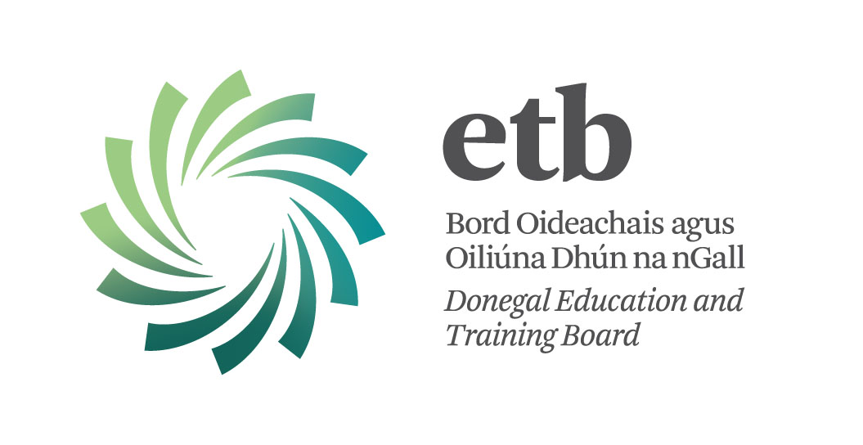

Special Needs Assistants

Confined Competition

Only people who are members of the Supplementary Assignment Panel 2013/14 may apply (See CL 37/13 on Department of Education and Skills website www.education.ie).

Donegal ETB invites applications from suitably qualified members of the Supplementary Assignment Panel 2013/14 for posts as Special Needs Assistants for the 2013/14 school session as follows:

Coláiste na Carraige, Carrick: 1 whole time post (32hrs) - REF: SNA 1

Gairmscoil Chú Uladh, Ballinamore: 1 half time post (16hrs) – REF: SNA 2
Competency in the Irish Language is Essential

Gairmscoil Mhic Diarmada, Arranmore Island: 1 half time post (16hrs) – REF: SNA 3

Special Needs Assistants are recruited specifically to assist students with disabilities in an educational context.

Qualifications:
With effect from 1st September 2011, the minimum required standard of education for appointment to the post of Special Needs Assistant is:-
1. A FETAC level 3 major qualification on the National Framework of Qualifications, OR
2. A minimum of three grade Ds in the Junior Certificate, OR Equivalent
AND
FETAC Level 5 Certification in Childcare or related field of study is essential. Successful candidates must hold 8 modules as specified by FETAC for the purposes of certification for Childcare Level 5 award.

Hours: 32 hrs per week (whole-time) or 16 hrs per week (half time)
Salary: New Entrants after 1/1/2011 – 1st point €12.50 per hour to 15th point €20.13 per hour
Employed before 1/1/2011 – 1st point €13.89 per hour to 15th point €22.36 per hour

Application forms and further details are available from the undersigned:-
(i) on request by e-mail at: sandra@donegaletb.ie
(ii) on receipt of A4 s.a.e. (€1.05).

The closing date for receipt of completed application forms is:
12:00 noon on Wednesday 14th August, 2013.

Please Note:
- Shortlisting of applicants will take place.
- Completed application forms will not be accepted via e-mail.
- Late applications will not be considered.

Contact Details:
Sandra Mc Connell
Human Resources Division
Donegal ETB, Administrative Offices, Ard O’Donnell, Letterkenny, Co. Donegal
T: (074) 9161600 F: (074) 9161544 E: sandra@donegaletb.ie

Donegal ETB is an equal opportunities employer.

