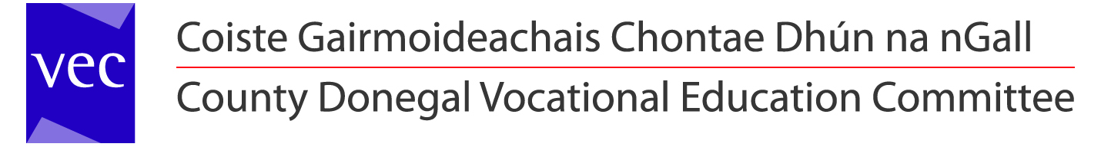

A chara,

County Donegal VEC currently make payments to Suppliers, Staff and Members of the Committee and Sub- Committees by Electronic Funds Transfer (EFT) and Payable Orders.

Under the Public Service Reform Plan and The Public Service Agreement (Croke Park), County Donegal VEC intend to make all payments due with effect from 1st May 2013 by means of Electronic Funds Transfer (EFT).

Please Note:
A Republic of Ireland Bank Account is required for EFT payment.
Failure to supply the required information below will result in payments being withheld pending receipt of the information requested below.

Therefore, we request that you complete in full and return the ELECTRONIC FUNDS AUTHORISATION below to:

Aidan Mc Closkey, Secretary LYCGS
Co Donegal VEC, Ard O’Donnell, Letterkenny, Co Donegal

Name of Club/Group
Treasurer’s Name |  |  |  |  |  |  |  | Telephone No.
Address |  |  |  |  |  |  |  | Email
R.O.I. Bank Name & Address
Account Number |  |  |  |  |  |  |  |  | Sort Code

I hereby authorise County Donegal V.E.C to lodge all payments due to this Company / Supplier, to the account details supplied herewith. I undertake to repay any payment(s) lodged to this Bank Account, to which I am not rightfully entitled. I declare that all information supplied by me in relation to the above is both true and accurate.

Signature: _________________________ Date ________________
Treasurer

Please have you bank affix its official stamp to confirm  the details provided are true and accurate. | [Official Bank Stamp]

